**TEAM ID: PNT2022TMID48132**

**PROJECT NAME: A NOVEL METHODF FOR HANDWRITTEN DIGIT RECOGNITION SYSTEM**

**CHARULATHA**

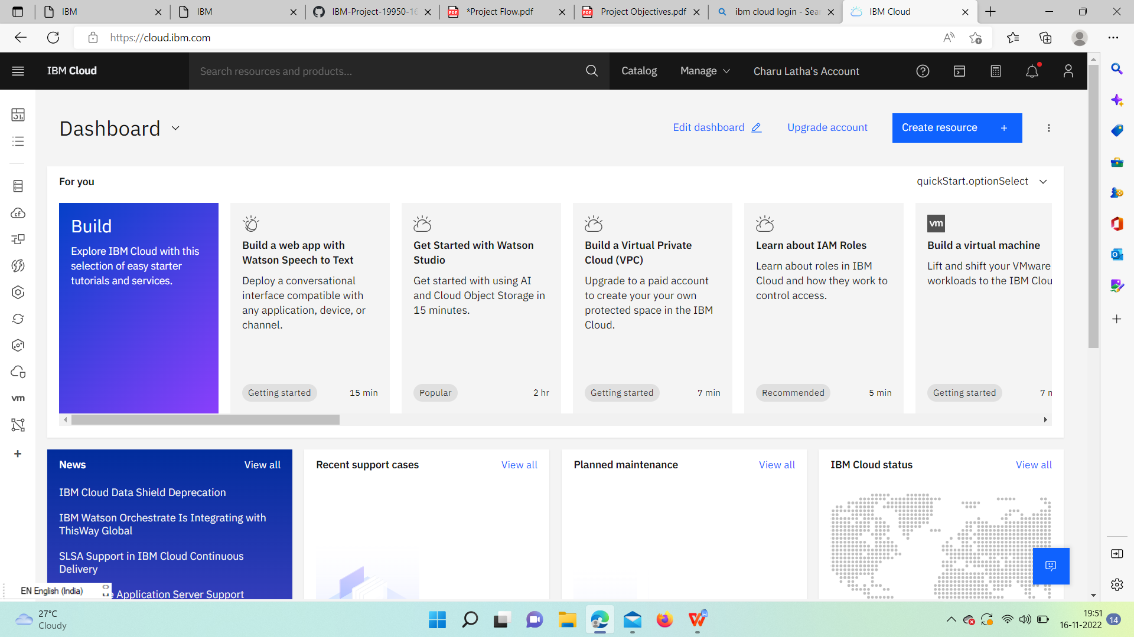

**DISOSA M**

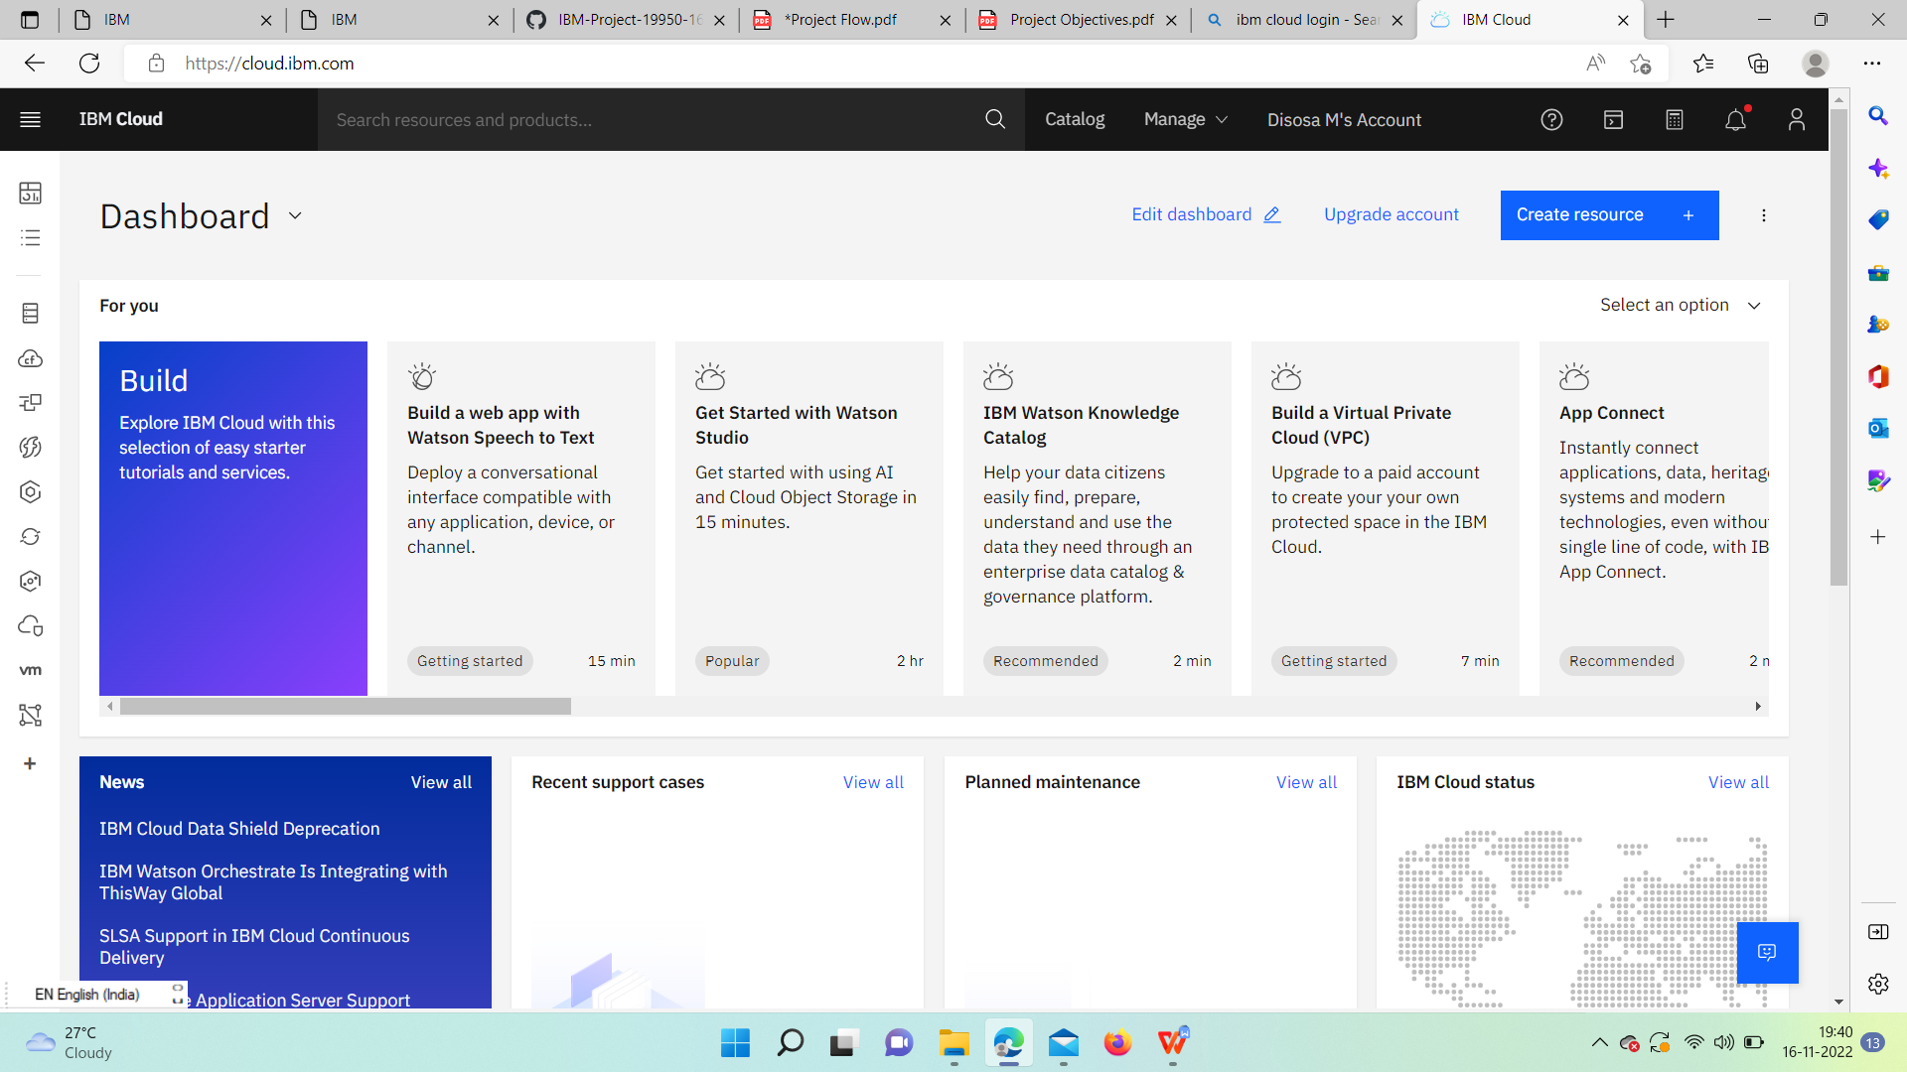

**GAYATHRI S**

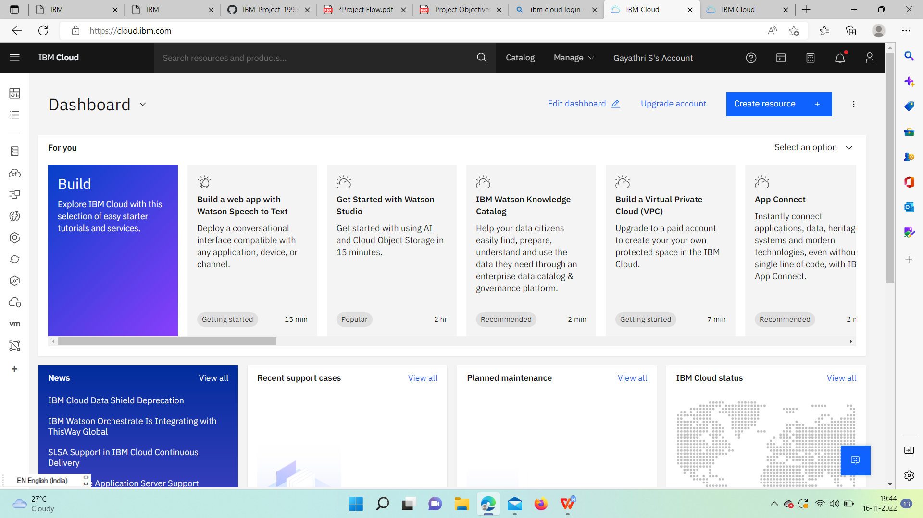

**JANANI R**

